- Purpose

To establish procedure to test and evaluate the glass assemblies prior to building the electrode assembly used in the ClearView device.

- Scope

This procedure applies to test personnel, quality assurance personnel and supervision that are responsible for the assembly and testing of the glass electrode assembly for use in the ClearView device.

- Responsibilities
User | - Complies with the policy and procedure to perform testing.  - Ensures the most current version of this document is used when referenced.
Departmental Management | - Ensures departmental personnel are properly trained before using this policy or procedure.
Quality Assurance | - Performs inspection of all documentation to ensure that only glass assemblies that meet the acceptance criteria are released for use in device manufacturing.  - Files and maintains all testing documentation.

- Equipment

Test Fixture
Computer System (1282-1511) loaded with ClearView Software (ClearView)
Calibration Probe (06680)
Calibration Probe Cable (06683)
Oscilloscope
Voltage Divider
Glass Assemblies (1282-1016) Under Test

- Procedure

  - Record the revision level of the glass assembly lot under test on the Glass Assembly (1282-1016) Test Record (Record). Record the lot number and the lot quantity on the Record.
  - Carefully unfold glass assembly (1282-1016) from protective wrapping. Only handle glass with gloves and at the edges of the assembly.
  - Inspect glass assembly from a viewing distance between 6 to 12 inches for film, scratches, occlusions, streaks or lines that may indicate damage to the ITO coating. Segregate acceptable and rejected material.
  - Record the total quantity of passed and failed glass assemblies in the space provided. Clearly label all failed glass assemblies. Only Acceptable glass assemblies will continue to be tested.
  - Each glass assembly will be assigned a unique serial number which will consist of the lot number (typically- 120518-01 which represents the first delivery- 01 on 5/18/12) followed by an alpha character. In this example, the first glass assembly tested from lot 120518-01 would be 120518-01-A and the second would be 120518-01-B, etc.
  - Duty Cycle Testing
    - Test Fixture Set Up

    - Place the glass assembly into the test fixture.
    - Open the ClearView Software. Click the Settings button on the application toolbar.
    - Using the arrow icon next to the Boost Voltage setting, raise the boost voltage to 160V (max). Click Save.
    - Click the Camera icon on the application toolbar. The Scanner Calibration window (See Figure 1) will open.

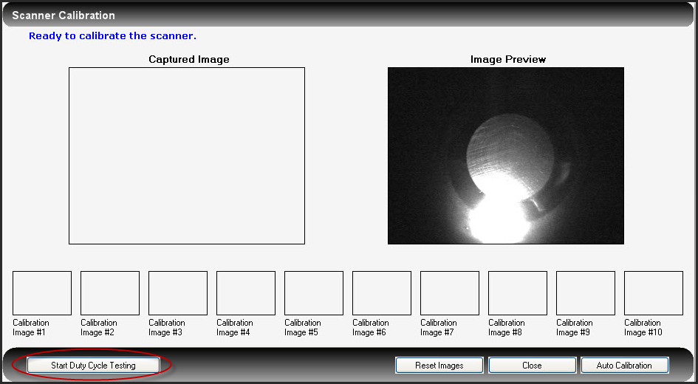
Figure 1

    - Initiate duty cycle testing by clicking the Start Duty Cycle Testing button in the lower left corner of the Scanner Calibration window. The device will begin to cycle application of energy to the glass electrode in 0.5 second bursts. An energized image will be displayed Captured Image box on the left and the Image Preview will display a live image cycling between energized images and the static image displayed in Figure 1 above.
    - The number of images collected will be visible in the upper left corner of the Scanner Calibration window. Run the duty cycle imaging for a minimum of 100 cycles. Monitor the glass electrode in the fixture during the entire 100 cycles watching the glass surface closely for changes in the surface that appear as fine lines that may appear to look like cracks.
    - If fine lines or other catastrophic failure is observed (See Figure 2 below), stop the Duty Cycle Test by clicking the Stop Duty Cycle Test button in the lower left corner of the Scanner Calibration window. Record Fail on the Record and label the glass assembly as Fail.

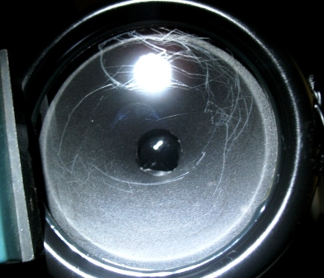
Figure 2

    - If no failure is observed after a minimum of 100 cycles, the test is concluded and the glass assembly is labeled Pass.
    - Remove the glass assembly from the test fixture. Place the glass assembly in the original protective packaging and label the assembly with the serial number (if not already done so) and the result of the Duty Cycle test.
    - Record the serial number and the test result (pass or fail) in the space provided on the Record.
    - Repeat the process until all glass assemblies have been tested.
    - Record the total quantity of passed and failed glass assemblies in the space provided. Ensure that all glass assemblies are label either pass or fail. Only acceptable (passed) glass assemblies will continue to be tested.
  - 2.5k Ohm Resistor Testing
    - Test Fixture Set-Up
      - Connect the Electrode Test Fixture to the 2.5k Ohm Resistor and the voltage divider as shown in Figure 3 below.

Figure 3

    - Place the glass assembly under test into the test fixture.
    - Open the ClearView Software. Click the Settings button on the application toolbar.
    - Using the arrow icon next to the Boost Voltage setting, raise the boost voltage to 160V (max). Click Save. The Settings window will close automatically.
    - Click the Camera icon on the application toolbar. The Scanner Calibration window (See Figure 1) will open.
    - Initiate a calibration images capture by clicking the AutoCalibration button in the lower right corner of the Scanner Calibration window. The device will begin to cycle application of energy to the glass electrode in 0.5 second bursts. The first five images are not stored and the next 10 images are displayed in the Calibration Image boxes at the bottom of the window.
    - While the calibration images are being taken, evaluate the high voltage and damped oscillation voltages and frequencies. Record the serial number of the glass assembly under test and the kV measured in the space provided on the Record.
    - If fine lines or other catastrophic failure is observed (See Figure 2 above), wait for the auto calibration cycle to complete. Record Fail on the Record and label the glass assembly as Fail.
    - If no failure is observed and the glass assembly voltage is within X and X, the test is concluded and the glass assembly is labeled Pass.
    - Remove the glass assembly from the test fixture. Place the glass assembly in the original protective packaging and label the assembly with the serial number (if not already done so) and the result of the 2.5 k Resistor test.
    - Record the serial number and the test result (pass or fail) in the space provided on the Record.
    - Repeat the process until all glass assemblies have been tested.
    - Record the total quantity of passed and failed glass assemblies in the space provided. Ensure that all glass assemblies are labeled either pass or fail.
  - Documentation review and release
    - Review the documentation for completeness and accuracy. Good manufacturing record keeping must be observed (reference EPIC’s Document Corrections procedure). Any errors or missing information must be completed prior to proceeding to release the product.
    - Failed Product
      - Total all glass assemblies that have failed and record the total number of assemblies that are rejected to MRB for disposition in the space provided on the Record.
      - Process all glass assemblies which have failed the inspection according to the Non-Conforming Material procedure.
      - Ensure that all failed glass assemblies have been properly labeled. Forward all material to QA for quarantine and MRB review.
    - Passed Product
      - Total all glass assemblies that have passed and record the total number of assemblies that are released in the space provided on the Record.
      - Ensure that all glass assemblies have been properly labeled for release. Reference EPIC’s Inspection and Release of Incoming, In-process and Finished Devices and Other Materials procedure for labeling instructions.
      - Forward materials to the appropriate stock location. File the inspection report by the part number and lot number. Inspection records are to be maintained in secure location with limited access.

- Reference
1282-1016, Glass Assembly
QA-007, Document Corrections
QA-016, Inspection and Release of Incoming, In-process and Finished Devices and Other Materials
QA-017, Non-conforming Material
QAF-011, Non-Conforming Material Report

- Attachments
Attachment A

Part Number: |  | Lot Number: | Serial Number:
Step 4.1 Lens holder inspection:
Calipers Device Number: Cal Date:
Depth Measurements (3.25 mm or greater)
1. 3.
2. 4.
Step 4.3 VLounge Operational Check (record specific descriptions of any connectivity and performance failures):

Step 4.17 VLounge Operational Check (record specific descriptions of any connectivity and performance failures):

Step 4.21 Image Sensor Inspection (record specific descriptions of any connectivity and performance failures):

Step 4.26 Lens holder Inspection (record specific descriptions of any connectivity and performance failures):

Step 4.31 VLounge Operational Check (record specific descriptions of any connectivity and performance failures):

□VLounge Image Attached
Step 4.31 ClearView Operational Check (record specific descriptions of any connectivity and performance failures):

□ClearView Image Attached
Pass  Fail | Signature: |  | Date:

QA Inspection
Inspection Point |  | Pass | Fail
The ccd Camera Disassembly and Test Record is completed accurately to requirements
Cameras meet all performance and inspection criteria
Other:
Other:
Notes:

Pass/Fail Determination: | Signature: |  | Date:

